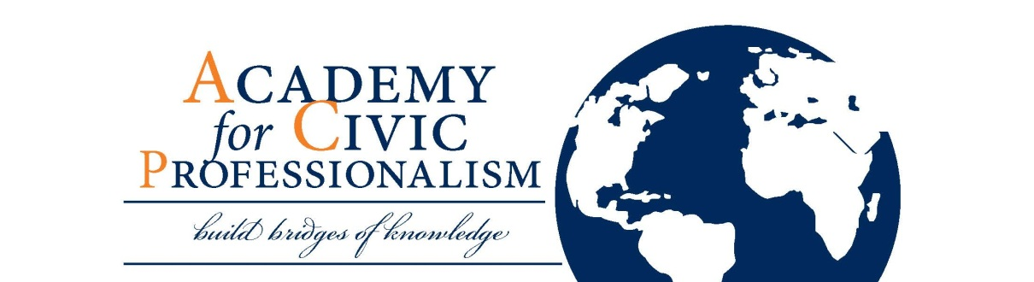

2014 SCHEDULE – Auburn Arena

SUNDAY, May 11

2:30 – 3:30 Imagining America at Auburn University
Kevin Bott, PhD, Associate Director of Imagining America

3:30 – 5:30 Education and Civic Professionalism Discussion (with K-12 teachers & administrators, Engaged Scholars, & civic key players)

5:30 – 7:00 Pre-Academy Reception

MONDAY, May 12

8:30 – 9:00 Arrival/Refreshments/Registration

9:00 – 9:30 Welcome and Introductions
Joe Aistrup, PhD, Dean
College of Liberal Arts, Auburn University
Giovanna Summerfield, PhD, Associate Dean for Educational Affairs
College of Liberal Arts, Auburn University
Brigitta Brunner, PhD, Professor
School of Communication and Journalism, Auburn University
ACP Participants

9:30 – 9:50 ACP Overview: Structure, Material, Objectives, and Assessment

9:50 – 10:40 What is Civic Professionalism? What is Professionalism in the Liberal Arts?
Giovanna Summerfield, PhD, Associate Dean for Educational Affairs
College of Liberal Arts, Auburn University
Brigitta Brunner, PhD, Professor
School of Communication and Journalism, Auburn University
10:40 – 10:50 BREAK

10:50 – 12:00 Democracy's Education - Reinventing Citizenship as Public Work
Harry Boyte, PhD, Founder of Public Achievement and Senior Fellow at the
Humphrey School of Public Affairs at the University of Minnesota

12:00 – 1:00 LUNCH

1:00 – 2:00 Who Are the People in Your Classroom? Profiles of Today’s College Students
Brigitta Brunner, PhD, Professor
School of Communication and Journalism, Auburn University
#civicprofessionalism

2:00 – 2:30 Career and Civic Professionalism: Helping Students See the Big Picture
Addye Buckley-Burnell, MEd, Assistant Director of Career Development
Auburn University Career Services
2:30 – 3:00 How to Use Social Media as a Professor and as a Connection with Community Partners Robert French, MA, Adjunct Professor
School of Communication and Journalism, Auburn University

3:00 – 3:10 BREAK

3:10 – 4:00 Planning a Course: How Civic Professionalism can be Added to Your Syllabi
Ann Knipschild, PhD, Professor
Department of Music, Auburn University

4:00 – 4:15 Assessment Tips

4:15 – 5:00 Article Discussion/Wrap-up

**dinner on your own**

#civicprofessionalism

TUESDAY, May 13

8:30 – 9:00 Arrival/Refreshments

9:00 – 9:30 Integrating Teaching, Research, and Outreach: A Framework for Scholarship and Tenure and Promotion Strategies
Giovanna Summerfield, PhD, Associate Dean for Educational Affairs
College of Liberal Arts, Auburn University
Barbara Baker, PhD, Executive Director, Women's Leadership Institute
College of Liberal Arts, Auburn University

9:30 – 10:50 Developing Civic-Minded Professionals: Findings from Research and Implications for Good Practice
Julie Hatcher, PhD, Executive Director of the Center for Service and Learning and
Associate Professor of Philanthropic Studies at Indiana University-
Purdue University Indianapolis

10:50 – 11:00 BREAK

11:00 – 12:00 Hands-on Syllabi Building/Revising Workshop
Ann Knipschild, PhD, Professor
Department of Music, Auburn University

12:00 – 1:00 LUNCH

1:15 – 1:45 LUCIA Lab Site Visit

2:00 – 2:40 Sustainability Site Visit

3:00 – 3:30 Raycom Studio Site Visit

4:00 – 5:00 Discussion with Charlotte Maddox from Auburn Public Housing
310 Tichenor Halll

**dinner on your own**

#civicprofessionalism

WEDNESDAY, May 14

8:30 – 9:00 Arrival/Refreshments

9:00 – 10:00 ACP Award Presentations
María Luisa López Segura, PhD, Researcher and Professor, ACP 2013 Participant
Instituto Tecnológico de la Laguna, Mexico

10:00 – 10:10 BREAK

10:10 – 11:30 Narrative and the Civic Professional – A Personal Reflection on Campus Cartography
Lorraine McIlrath, MA, Coordinator of the Community Knowledge Initiative
at the National University of Ireland Galway, Principal Investigator
and Co-Founder of Campus Engage

11:30 – 12:00 Resources for Engagement: Grants and Research, Networking and Memberships
Giovanna Summerfield, PhD, Associate Dean for Educational Affairs
College of Liberal Arts, Auburn University
CCE Grant Recipients
Matthew Hoch, PhD, Assistant Professor
College of Liberal Arts, Auburn University
Iulia Pittman, PhD, Associate Professor, and Beth Lauritson, Student
College of Liberal Arts, Auburn University

12:00 – 1:00 LUNCH

1:00 – 1:15 Engaged Scholar
Angie Burque (Braveheart), MSW, Associate Clinical Professor and Social Work Field Coordinator, Department of Sociology
College of Liberal Arts, Auburn University

1:15 – 1:45 Social Entrepreneurship
Sandra Clark-Lewis, PhD, Auburn University Audiology Outreach in Guatemala
College of Liberal Arts, Auburn University
Maggie Moore, Student, Community & Civic Engagement Club President
College of Liberal Arts, Auburn University

1:45 – 2:30 International Internships
Meaghan Hanson and Ali Stephanek (Guatemala experience), CMDA Students
College of Liberal Arts, Auburn University
Kelsey Hayes (Paris experience), Graduate Student, CCE Minor
College of Liberal Arts, Auburn University
Ric Smith, MA, MEd, MDIA Faculty and Internship Director
College of Liberal Arts, Auburn University
#civicprofessionalism

2:30 – 2:45 BREAK

2:45 – 3:45 How to Mentor Graduate Students as Civic Professionals
Kathleen Hale, PhD, Associate Professor
College of Liberal Arts, Auburn University
Brigitta Brunner, PhD, Professor
School of Communication and Journalism, Auburn University
Melani Landerfelt, MA, Community and Civic Engagement Graduate Assistant
College of Liberal Arts, Auburn University

3:45 – 4:15 Citizen Alum at Auburn
Mark Wilson, PhD, Director of Civic Learning Initiatives
College of Liberal Arts, Auburn University

4:15 – 5:00 Concluding Remarks, Presentation of Certificates, Group picture

#civicprofessionalism

