BraveHearts Phase 2: Center for Place and Purpose
Intern Application Packet

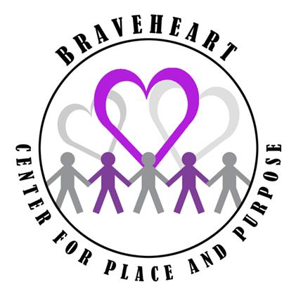
New Internship Site: Seeking highly motivated, dependable, personable, and adaptable students who want to grow and enhance professional knowledge and skills in an innovative, challenging, strengths based and training focused new community program for young adults with disabilities facing moderate to severe life challenges.

This Intern Application Packet includes:

- A description of Internship responsibilities and tasks at BraveHeart Center for Place and Purpose
- A BraveHeart Center for Place and Purpose Application for Internship form
- A BraveHeart Center for Place and Purpose Intern Development, Training and Evaluation Form (to be completed mid-semester and end of the semester by the Program Coordinator or Program Director.)

Primary Internship Tasks:
- Responsible for providing assistance and support to students during the daily, weekly and monthly operations of the Center
- Assist with preparing and implementing successful transitions for Center arrivals and departures
- Engage and successfully relate to each unique student and family with respect and integrity at all times
- Demonstrate familiarity with each student’s strengths and needs in order to anticipate anxieties and stressors and plan interactions accordingly
- Provide support and encouragement as students are assisted to move through the daily activities and curriculum
- Demonstrate patience and openness in all interactions with students and their families
- Maintain student records as well as complete needed documentation - progress notes, home-school communication folders, and process recordings and professional development notes
- As directed by Program Coordinator, assume primary responsibility for morning or afternoon schedule of activities
- Participate in supervisory meetings with Program Coordinator and/ or Program Directors as directed (At least every 3 weeks)
- Demonstrate consistent dependability by arriving and leaving on time
- Act as a community liaison. Contact surrounding businesses and area organizations for possible sponsorships and collaborative work opportunities
- This is a 4-5 day internship setting. Center for Place and Purpose (CPP) Administrative and Community Outreach activities will occur mostly on Mondays, as students attend CPP, Tuesday – Friday.

Minimum Qualifications:
- Applicant must be an AU student registering for graduate assistantships, undergraduate internships, and/or practicum (3-4 days/week - minimum 25 hours per week) in a professional helping discipline.
- Preference is given to qualified and appropriate students majoring in: Rehabilitation Services, Social Work, Kinesiology, and Special Education.
- Interested applicants must provide a copy of their AU transcript, a letter of recommendation from a professor in the student’s major as well as a second letter of recommendation.
- Potential CPP Interns must have the following qualities and experiences:
  - Demonstrated and verifiable success in effectively working with persons with moderate-severe disabilities
  - Ability to infuse all CPP interactions with patience and openness
  - A desire and ability to provide support, encouragement and kindness in each interaction with students, their families, and all other CPP staff
  - Consistency in being physically, mentally and emotionally present for the students each day
  - Have no history of attendance issues related to other college courses and /or volunteer or practicum experience (Persons with a past history of attendance issues, etc. are excluded from this position.)

Application Process:
1. Contact Angie Burque burquad@auburn.edu for CPP Application for Internship
2. Return completed CPP Application for Internship, 2 letters of Recommendation and copy of College Transcript. (You may scan this information initially, providing a hard copy if contacted for interview).
3. Program Directors and/or the on-site Program Coordinator will contact selected applicants for an initial interview;
4. Applicant must obtain and provide a statement of clearance from the Child Abuse registry and a criminal background check. The applicant must cover the cost of these clearances.
5. When potential interns do not have BraveHeart experience, a 2nd interview which includes a Program Director and/or Program Coordinator and 1-2 representatives from the family advisory group may be required. In addition, a small group interactive experience with 2-3 CPP students may occur at this time also;
6. Within 1 week of acceptance in BraveHearts CPP Internship Program, prospective intern must complete the online Alabama Department of Human Resources mandated Reporter Training and provide the Certificate of Completion to Center Director.

Work Schedule: The Center's on-site hours are Tuesday-Friday 7:30am-3:30pm and follows the University Academic Calendar for programming. There will be opportunity to obtain hours on Mondays through administrative tasks, supervision meetings and community outreach. The Program Coordinator will work with individual interns to establish a schedule that supports needed hours for student’s Practicum or Internship course.

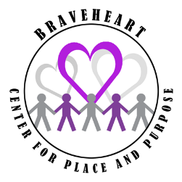 BraveHeart Center for Place and Purpose
Application for Internship

Name: ______________________________________ Major: _______________________
Address: ______________________________________________________________________
Phone: ________________________ Email: ________________________
Intern Course - Program/Number/Title (i.e. SOWO 4920: Social Work Internship):
____________________________________________
Total Hours needed for this course: ______
Overall GPA in Major: ______ Overall GPA at Auburn University: ______
Have you ever volunteered with BraveHeart? Yes _____ No _____
If so, when? ____________________________________________________________
- What interests you about an internship with BraveHearts Center for Place and Purpose?

- What experience(s) have you had with persons with disabilities, especially those facing moderate to severe life challenges?

- What strengths do you bring to BraveHearts Center for Place and Purpose?

- How would an internship with BCPP benefit your long term Career Goals?

BraveHeart Center for Place and Purpose
Intern Development, Training and Evaluation Form

Intern: ____________________________________ Major: ________________________
Completed by: ______________________________ Date: __________________________
Major accomplishments during internship: _____________________________________________________
_________________________________________________________________________________________
_________________________________________________________________________________________

 | Excellent | Very Good | Average | Fair | Poor
Dependability

Attendance
Promptness
Emotional Maturity
Verbal Communication Skills
Demeanor/Disposition
Ability to Work Independently
Ability to Understand & Adhere to Organizational Structure, Policies, and Procedures
Ability to Work Effectively with Program Students

Ability to Fulfill Commitments/Responsibilities

Ability to Manage Stressful Situations
Ability to Follow Instructions
Ability to Accept Correction/Constructive Feedback

Ability to Work as a Member of a Team

Task Performance

Summary of strengths and needs/Goals to be completed:
________________________________________________________________________________________________________________________________________________________________________________________________________________________________________________________________________________________________________________________________________________________________________________________________________________________________________________________________________________________________________________________________________________________________________________________________________________________________________________________________________________________________________________________________________________________________________________________________________________________________________________________________________________________________________________________________________________________________________________________________________________________________________________________________________________________________________________________

Intern Supervisor Signature: _____________________________ Date: __________________

Intern Signature: ______________________________________ Date: __________________

